



**Revision History**

| **Date** | **Version** | **Author** | **Change Description** |
| --- | --- | --- | --- |
| 03/12/2024 | 0.1 | Le Thanh Loc, | Initial creation |
|  |  |  |  |
|  |  |  |  |
|  |  |  |  |

**Table of Contents**

1 Objective and Scope 3

2 Business Requirement 3

2.1. Application Overview 3

2.2. Domain Model 4

2.2.1. Diagram 4

2.2.2. Domain Objects Description 4

2.3. Workflow 5

Workflow Description: 5

Workflow Description: 6

Workflow Description: 7

2.4. Use Cases and Actors 9

2.4.1. Diagram 9

2.4.2. Description of Actors 10

2.4.3. Description of Use Cases 10

2.5. Security Matrix 10

3 Appendix 12

3.1. Glossary 12

3.2. Open Issues 12

# Objective and Scope

This document describes the business requirements for the STYLLE Project. It contains the overall description of the application, the scope of data migration, and any changes need to be performed during migration of the application.

This document along with the prototype demo is used for requirements confirmation, and it is to be signed off by the business. Details of business logic and graphic user interface of the application, which are not mentioned in this document, will be migrated as they are in the application.

# Business Requirement

## Application Overview

STYLLE is a mobile application designed to be a social photo sharing platform. It allows users to easily share and discover memorable moments through photos. The app provides a unique communication and interaction experience, where users can share their personal photos, engage with each other, and explore a diverse range of images from around the world.

Key Features:

* Photo Sharing: STYLLE enables users to upload and share their favorite photos with their followers and the wider community. Users can add captions, tags to provide context and enhance the storytelling aspect of their photos.
* Explore and Discover: The app offers a rich browsing experience with a dedicated explore section. Users can discover trending photos, popular hashtags, and explore different categories to find inspiration and connect with like-minded individuals.
* Social Interactions: STYLLE emphasizes social interactions by allowing users to follow other users, like and comment on photos, and engage in conversations. This fosters a sense of community and encourages users to connect, collaborate, and share their thoughts and feedback.
* Personalized Feed: The app provides a personalized feed that curates content based on users' preferences, interests, and interactions. This ensures that users are presented with relevant and engaging content that aligns with their preferences.
* Privacy and Security: STYLLE prioritizes user privacy and offers various privacy settings. Users can choose to make their profiles public or private, control who can view and interact with their photos, and manage their personal information.
* Notifications: The app keeps users informed about new followers, likes, comments, and other important activities through push notifications. This helps users stay connected and engaged with the community.

STYLLE aims to create a vibrant and inclusive community of photo enthusiasts, fostering creativity, inspiration, and meaningful connections through the shared love for photography.

## Domain Model

### Diagram

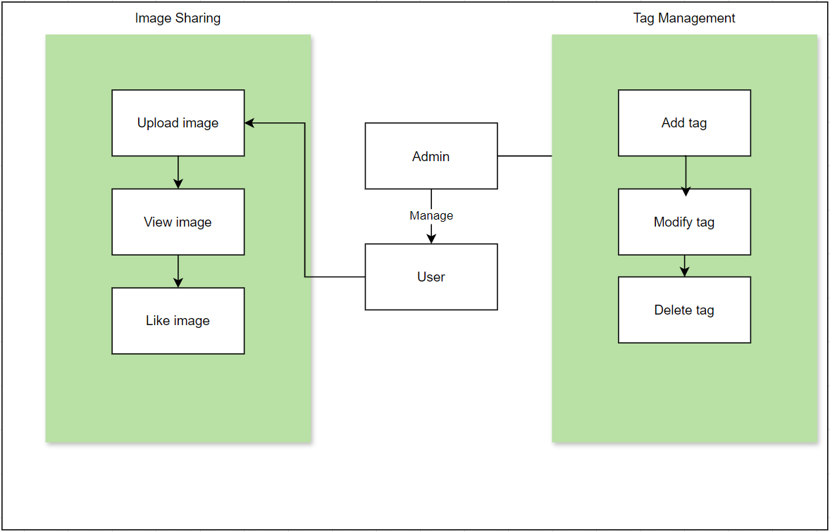

*Figure 2.2.1. Domain diagram for STYLLE*

## Use Cases and Actors

### Diagram

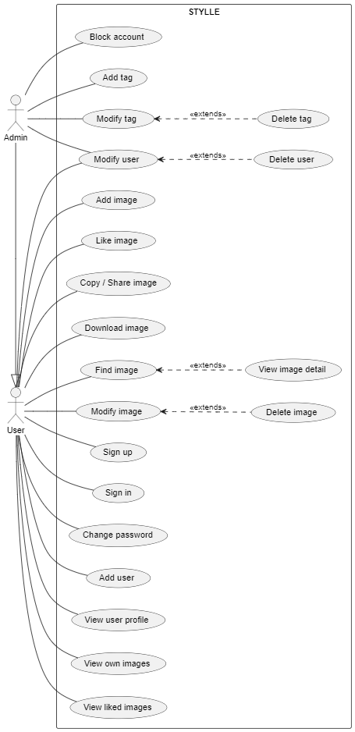

*Figure 2.4.1. UC diagram for STYLLE*

### Description of Actors

| # | Actor Name | Definition |
| --- | --- | --- |
| 1 | Admin | Persons in this group have full control over the system, they mainly manage all the staff, manage images, manage tags. |
| 2 | User | Persons in this group can managing their own account or images they uploaded and view other photos. |

### Description of Use Cases

| # | Use Case Name | Definition |
| --- | --- | --- |
| **1** | **Sign up** | This use case allows users to sign up their own account |
| **2** | **Sign in** | This use case allows users to sign in with their account |
| **3** | **Change password** | This use case allows users to change their account password |
| **4** | **“User” related** |  |
|  | Modify user | Update profile information |
|  | Delete user | Delete account |
|  | View user profile |  |
|  | View own images | View images that the user posted |
|  | View liked images | View images that the user liked |
| **5** | **“Image” related** |  |
|  | Find image | Look for images that match certain keyword |
|  | View image detail |  |
|  | Add image | Upload image (from Gallery or Camera) |
|  | Modify image | Update image description, tags |
|  | Delete image |  |
|  | Like image |  |
|  | Copy / Share image |  |
|  | Download image | Download image to phone |
| **6** | **“Tag” related** |  |
|  | Add tag |  |
|  | Modify tag | Update tag’s name, image |
|  | Delete tag |  |

## 

## Security Matrix

|  | Actor  Function | Admin | User |
| --- | --- | --- | --- |
| **1** | **Authentication** |  |  |
|  | Sign up |  | x(*) |
|  | Sign in | x(*) | x(*) |
|  | Change password | x(*) | x(*) |
| **2** | **“Image” related** |  |  |
|  | Upload, Edit, Delete own image |  | x(*) |
|  | View list of images, detail of an image |  | x |
|  | Like |  | x |
|  | Download |  | x |
|  | Copy/Share |  | x |
|  | View related Images |  | x |
|  | Search image by tag, user name |  | x |
|  | Filter images by newest, most popular, tags |  | x |
| **3** | **“User” related** |  |  |
|  | Edit profile | x | x(*) |
|  | Update profile image |  | x(*) |
|  | View own images |  | x(*) |
|  | View liked images |  | x(*) |
|  | Block account | x |  |
| **4** | **“Tag” related** |  |  |
|  | Add tag | x | x(*) |
|  | Modify tag | x |  |
|  | Delete tag | x |  |

X: User has full permission to do the action.

X (*): User has permission to do the action on his own items.

# Appendix

## Glossary

| Term | Description |
| --- | --- |
| BRD | **B**usiness **R**equirements **D**ocument |
| DB | **D**atabase |
| STYLLE | Sharing Photos Social Media |
|  |  |

## Open Issues